No paper headers for 7th edition APA!
Page number to top right

Writing Style and Mechanics: Example Paper (bolded)

Student Name
Denver College of Nursing
Course Number: Course Name
Professor Metcalf
Date

Title of Paper in Mostly Uppercase (Title, Centered, Bolded)
Start with an introduction to your paper. You will grab the reader’s attention and make the reader excited to read on. Next, support that opening sentence with discussion on the topics you will address in the paper, being careful not to give away the punch line too soon. It’s a great idea to introduce topic with a little research. According to Metcalf (2020), don’t go too crazy on the research just introduce the research. This paragraph should not be longer than a half page at most. Do not use an abstract for this paper. APA success requires knowledge of the format and skill in concise, clear written communication (Smith, 2016). This APA format is taken from the newest APA book (7th ed.). The last sentence of the introduction should highlight the paper, for example: ‘In this paper, you will learn about how to implement APA formatting to be successful with writing’. Implementing this as your final sentence will lead the reader forward eagerly.

*Using the Rubric, ensure all points are included in your introductory paragraph. Research must be introduced by using citations, at least one pro and one con. Not to exceed 1/2 of the page and at least 5-7 sentences.
*Use 1-inch margins and Times New Roman or Arial font

References (centered, bolded, & alphabetized with hanging indent)
Copeland, L. (2016). Title of article in mostly lowercase except first words, first words after a colon or proper nouns. Source of Article in Mostly Uppercase and Italics, 149(5), 35-142. http://www.weblinkmustactuallywork.com
Lawton, K. A., Cousineau, L., & Hillard, V. E. (2016). Title of article in mostly lowercase except first words, first words after a colon or proper nouns. Source of Article in Mostly Uppercase and Italics, 21(1), 35-42. https://www.lib.duke.edu/libguide/plagerism.htm
Smith, A. (2016). Book in italics and mostly lowercase (6th ed.). Washington, DC: Author.

See appendix or how to set up a Hanging Indent. If after reviewing this appendix it still doesn’t make sense how to format a Hanging Indent, please look up in YouTube how to do this including the exact type of computer and software and you should be able to find a very detailed visual!

Appendix: Directions for a Hanging Indent (Centered & Bolded)
- This is for Word (2011). For other computer versions, please see YouTube for a video of how to set this up. It will be similar to this, but not quite the same.
- Make sure your cursor is on your reference page prior to setting up this format.
- Click on ‘Format’ and scroll down to ‘Paragraph’.

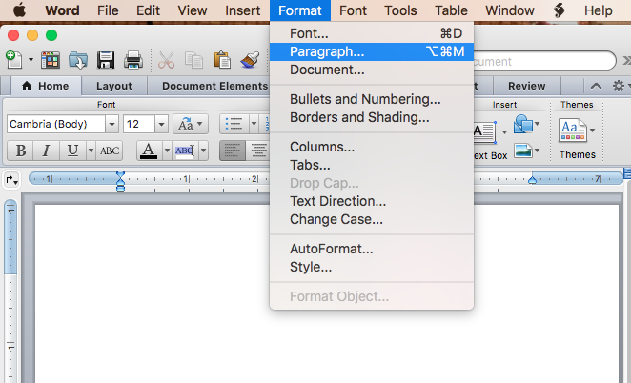

- In the ‘Special’ list under ‘Indentation’ select ‘Hanging’, and the ‘By’ list select ‘0.5’.

